Put your title here (Times New Roman 14 bold)

First name Last name¹, First name Last name², First name Last name ^{1, 3} (Times New Roman 12 bold)
¹ Put your first affiliation here (Times New Roman 12 italic)
²Graduate School of Science and Engineering, 255, Shimo-Okubo, Sakura-ku, Saitama 338-8570, Japan
E-mail: contact.author@somewhere.world (Times New Roman 12 italic)

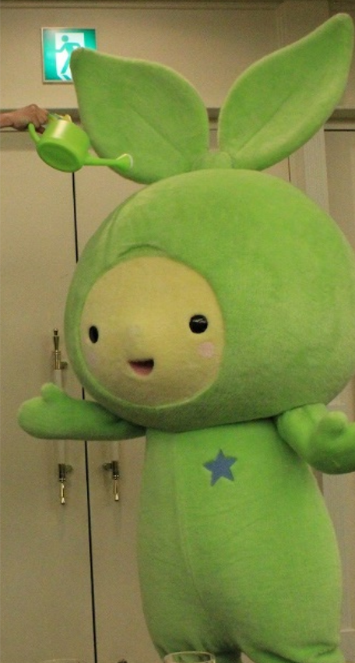
Abstract must be within 1 page. Please submit your abstract in a pdf file (only a pdf file is receivable).
Put your abstract here. The text style should be “Times New Roman, 12” with 2 cm margins top, bottom, left and right.
The abstract may include figures. They should be associated with a caption including the figure number (1, 2, 3…) and the description as presented in the sample below.

The figures should be referenced in the text as follows: Fig. 1. In the text, the reference number should appear as an reference ^{[1]} and references^{[1,2,3]} The reference list should appear at the end of the abstract in a section titled References. For websites^{[3]} indicate the full URL.
Figure 1. Put the figure caption here. When needed, reference the different elements of the image with letters a, b, c… and put the corresponding description as follows: a) First comment here, b) Second comment here,…(Times New Roman 10)
* This is the Merin-chan, the mascot of Saitama University. Please delete it from your abstract.
Funding should be indicated separately before the acknowledgement. Indicate the funding source and the grant number.

References: (Times New Roman 11)
[1] ******************************
[2] ******************************

